### **StorytelHER Record01 — One Day at a Time!**



Imagine yourself to be the lead protagonist of the plot where you were lost in a place, confused and not ready to adopt the changes but you do not have any other option as you need to get out and help yourself.

This situation matches with the initial days of our proponent of the StorytelHER Record01, **Madhura Joshi.**

Starting from an introvert back in school to the founder of Girls who Code Chennai, her journey is no less than a roller coaster ride.

It was back in 2016 when Madhura chose to explore this new domain of Computer Science and got admitted to an engineering college in Chennai, Tamil Nadu. Being a biology student, this domain was very challenging for her. Though she chose this out of interest, Madhura could not find any women mentors to guide her into this domain.

She stated,

As I could not find enough resources on my own, I went to my HOD for help and she introduced me to this new computer science club in my college. I got into my first ever workshop with much excitement but I was surprised to find myself as the only woman around. That day, I decided to open a women based community in the domain of tech and had ended up founding Girls Who Code - HITS in my college.

Today the club has 130+ members and is growing rapidly by conducting meetups, hackathons, and blogging about the events to motivate everyone around to join tech by highlighting the perks of being into it. We are also planning to incorporate the placement related guidance and training for our juniors to excel in the recruitment season.”

Madhura has realized the power of community bonding and was comfortable in learning by helping others and vice versa. With this vision, she joined another community named **Build2learn** in Chennai.

Build to Learn is an initiative by a group of volunteers to help people learn programming by building useful micro-products. The major motto is — Build to Learn and Learn to Build.

The power of community to create health is far greater than any physician, clinic or hospital!

Being in Chennai and having the language problem did not affect her because she believes,

there will always be at least one person to help you out even in the middle of your worst experiences. So, you just need to find that one person to have control on your situation!

When asked about what advice she will be giving, she said,

“If I were to go back and advise something to my younger self, I would say to Start reading books a little earlier. Books are indeed the best way to learn and helps a lot in your thought process and personality development.

For other students, I strongly suggest that they take challenges and go for it,I want them to think that “what’s the worst that can happen, you will fail but think of the consequences that might go right”.

And to all the young women out there, I motivate them to learn to get out of their comfort zones and start working for the things they actually want. Things will fall into place sooner or later.”

Do not ruin things by overthinking!

The major dilemma we all are facing nowadays is to maintain the balance between our professional and personal lives and the idea of increasing the overall productivity of the day. Madhura has a unique way to deal with this, She explained,

Have something to look up to beyond your professional skills for exploring boredom, be it learning art, blogging, reading through new concepts, learning Turkish numbers.

Take up the trending challenges like the 30 days of productivity, 100 days of code, etc for developing a habit and maintaining a schedule. It will not only affect you personally but will also help you expand your horizons professionally.

Many times we lack motivation and self-confidence even after achieving a lot in our lives both personally and professionally, which is usually termed as **Imposter Syndrome.**

On this, Madhura shared her vision by stating,

“ We have faced it at one point or another so the only point of concern lies within how to handle it!

Last year, I was also going through the same feelings so I wrote all my achievements of 2019 in a blog where I have mentioned even the smallest of all the accomplishments and by the end of the year I have realised that the year was not as bad as I was thinking about it.”

Writing about your accomplishments not only helps in introspection and combating the Imposter Syndrome but it also works as a reference for later stages at times of your self doubt and despair!

She continued by saying,

“I don’t exactly remember how many times I have read it but every time it’s a feeling of satisfaction and pride looking back at the accomplishments which calm my anxiety to some extent and motivates me to work further.”

Writing and reading are complimentary. Reading from the experiences of others is equally important in the process of self-development and growth.

To my surprise, I have done 3 interviews to date and every protagonist of my story has recommended the same book,

Lean in by Sheryl Sandberg

This book covers almost all the topics of womanhood and has amazing insights for the women of any age group. Hence, this tops the list of must-read books by anyone especially women in the tech industry.

On asked about something that actually worked out for Madhura throughout her experience, she responds by saying,

Goal Setting!

I have a habit of writing down every single thing that I wanted to do(learned from the book GOALS by brian tracy) and when I see the goals repeatedly, I feel a special energy to work towards it!

Goal setting plays a very important role in your life because it’s only when you know where you want to go, you will be able to reach there. Also, you might feel lost as things will not be making sense, but as Steve Jobs rightly quoted that,

You can’t connect the **dots** looking forward; you can only connect them looking backwards. So you have to trust that the **dots** will somehow connect in your future. You have to trust in something — your gut, destiny, life, karma, whatever!

Once you start building the faith in your process, you will eventually see yourselves moving towards your goal no matter at what pace.

Also, not every opportunity comes with a success story, you will be failing because it is a part of the process. On failure management, Madhura has shared her vision,

I consider my failures as ways to reach success!

If you think that something did not turn out as you expected it to be, try to focus on the process and get at least one new thing you learned throughout. Focus on comparing yourself with your previous self rather than comparing yourself with others.

I, through my experience of interviewing leading personalities, personally believe that

Failure management is hard and you are feeling sad because it was supposed to be this way. There is no easy going.

So, take a break and dance, cry your heart out, eat or do whatever makes you get over it but learn to leave the past failure experiences and carry only the lessons on the further stages. The world is not going to end anyway!

This serves as one of the major reasons for less participation of women in any competitions as they take the failures too seriously.

As also noticed by Madhura,

There is less participation of women in competitions and related job opportunities because we women think a lot before taking any step compared to any other gender. We feel that we should be knowing 100% of the skill to apply for anything while according to a LinkedIn survey, men apply if they know about 60% of the job profile skills and hence we end up losing many opportunities in the due process.

There is no point in thinking too much!

If plan A fails, the language still has 25 more alphabets!

You just need to trust your abilities that you’ll figure it out and move ahead to have a competitive career and job profiles for constant motivation.

Madhura’s key to daily motivation is one quote,

“Your success yesterday means nothing, what you do today shapes your tomorrow.”

To summarise all the of my key learning and takeaways, I would like to conclude by stating,

Realise and acknowledge the changes within you each and every day, it’s a lifelong process, let it sink.

It will take time because it was meant to be a long process but you better focus on your part and consider

“One day at a time!”

 — — — — — — — — — — — — — — — — — — — — — — — —

**About Madhura Joshi**

She is the founder of Girls Who Code - HITS Chennai, a Women Techmakers Chennai Volunteer, Erasmus Student Exchange Program - Istanbul Turkey, Google Explore ML Facilitator, and a Machine Learning Enthusiast.

Contact details:

LinkedIn:

Twitter:

Medium:

**About the StorytelHER**

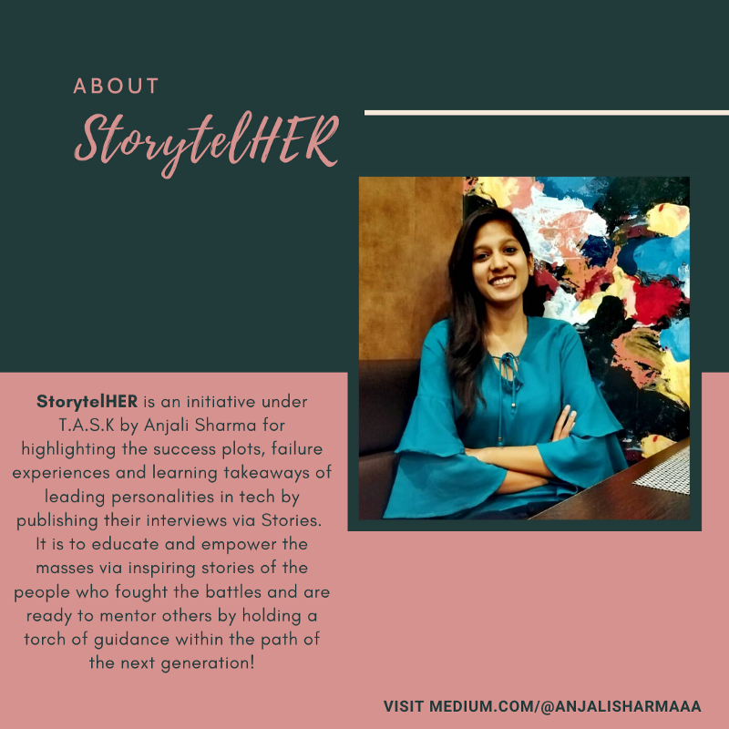

Thank you for reading!